**Construct the low pass filter on your Audio board**

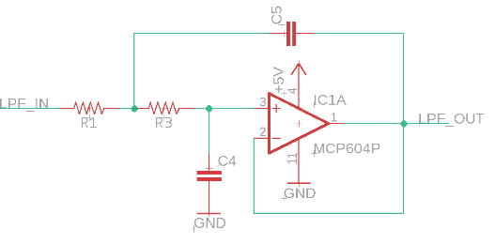

|  |  |
| --- | --- |
| Component | Value |
| R1 | 100kΩ |
| R3 | 1MΩ |
| C4 | 1nF |
| C5 | 10nF |

**Construct the high pass filter on your Audio board**

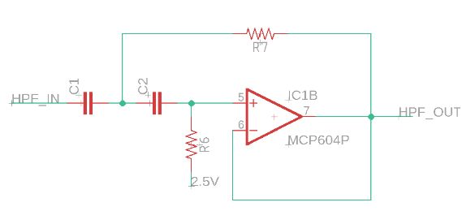

|  |  |
| --- | --- |
| Component | Value |
| R6 | 220kΩ |
| R7 | 47kΩ |
| C1 | 1.5nF |
| C2 | 1.5nF |

**Construct you band pass filter on your Audio board**

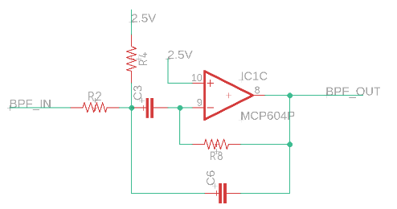

|  |  |
| --- | --- |
| Component | Value |
| R2 | 220kΩ |
| R4 | 22kΩ |
| R8 | 470kΩ |
| C3 | 3.3nF |
| C6 | 3.3nF |